2026 Application Form for Study in 2027
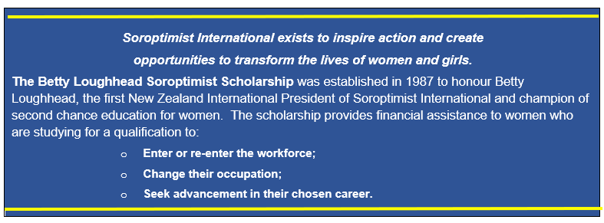
Scholarships are open to women who are:

● New Zealand citizens living and studying in New Zealand. Those holding a New
Zealand Resident visa and those on a New Zealand student visa are not eligible.

● Enrolled in full time study or part-time study of at least 50% of full-time equivalent, in an NZQA approved tertiary education programme.

● Have a proven record of achievement which demonstrates your ability to pass the course that you intend to enrol for.

● Able to use the scholarship in the 2027 academic year.

● Willing to participate in Soroptimist International promotional activities (if successful).

Applications open on 1 August. An electronic copy of your application in one single PDF file is to be sent to the Secretary secretary@blsst.co.nz by the closing date for applications: 31 August 2026.
Applicants will be notified of the trustees’ decision in November 2026.
Payment to successful applicants will be made on receipt of evidence of your
acceptance into your stated programme of study.

Important notes:

Please answer all questions on this form, taking note of the maximum number of points awarded for each section. Maximum points possible = 50.
Boxes will expand as you type your answers.
- Applications must be typed, preferably in Arial font size 11.
- Your completed application should be sent in one single PDF file only, to reach the Secretary, Betty Loughhead Soroptimist Scholarship Trust by 31 August, 2026. Multiple files and separate attachments will not be considered.
- Incomplete applications and those lacking supporting evidence where requested will not be accepted, so please check carefully before sending.

PLEASE READ THE INFORMATION ABOVE CAREFULLY BEFORE COMPLETING THIS FORM
1. Personal Information |  |  |  |  |  | No points, but this information is required.
Name of applicant:
Postal Address:
Telephone: |  |  |  |  | Email:
Date of Birth: |  |  |  |  | Place of Birth:
I am a New Zealand Citizen living in NZ: Yes / No (delete one)
INSERT Proof of NZ citizenship HERE (Copy of passport, birth certificate or citizenship certificate. Please note, a driving licence is not acceptable as proof of citizenship).
How did you learn about this scholarship?
(Answer in the box opposite)
2. Education |  |  |  |  |  |  |  |  |  | Maximum points  10
Please list qualifications already gained, the awarding institution and the year awarded. If you are part-way through a course of study, please attach evidence including transcripts of achievements to date.
Qualification (e.g. NCEA levels, Diploma, Certificate, Degree etc.) |  |  |  | Awarded by (Name of Institution) |  |  |  | Year Awarded
INSERT YOUR MOST RECENT ACADEMIC TRANSCRIPT HERE, WITH CONFIRMATION OF GRADES.
3. Your Study Plans |  |  |  |  |  |  |  |  | No points, but specific information is required.
3a. Which educational institution are you enrolled in (or intend to be) in 2027?
Name of institution:
Address:
Will your study be on Campus, Online, in a Summer School, or Other?
If ‘Other’, please describe:
3b. Name of the qualification – degree/diploma/certificate you aim to achieve on completion of this study: |  |  |  | Name of Certificate/Degree/Diploma:
3c. Year you will be enrolled in during 2027 (e.g. Year 1, Year 2, etc) |  |  |  | Year of study in 2027:
3d. Will your study be full time or part time in 2027? |  |  |  |  |  |  |  |  |  | Full time / Part time (delete one)
3e. If part time, please indicate % of FTE (full-time equivalent) that you will undertake in 2027. |  |  |  |  |  |  |  |  |  | If part time, % of FTE:
If part time, please explain why.
Box opposite will expand as you type.
4. Personal Background, Values and Achievements: Note - total for both 4a, 4b and 4c should not exceed 300 words. |  |  |  |  |  |  |  |  |  | Maximum points  10
4a. Tell us in the box below, something of your personal achievements that had a positive impact on for example your life, family/ whānau, school, marae and/or community.
4b. Challenges or adversity faced; demonstrated resilience, determination and/or perseverance in overcoming these.
4c. Community involvement including volunteer work, leadership roles, activities and/or contributions made to support others e.g. mentoring other students, volunteering with community organisations, supporting cultural or community events, advocating for equal opportunities, helping family members or whānau access education or community services, participating in projects that support women, girls and disadvantaged groups, sports coaching and any other community activities.
5. Your Goals: Not more than 500 words in total for 5a, b, c, and d. |  |  |  |  |  |  |  |  |  |  | Maximum points  20
5a. Please give us an ‘overall picture’ of how you see your future: Answer in the box below.
5b. Why do you want to do this study or training? Answer in the box below.
5c. What is your longer-term aim for employment? Answer in the box below.
5d. How will this employment enhance your ability to contribute to the well-being of women and girls for example your family, community? Answer in the box below.
6. Financial Circumstances: Not more than 200 words in total for 6a and 6b. |  |  |  |  |  |  |  |  |  |  | Maximum points  10
6a. How would receiving this scholarship help you to achieve your academic goals and advance or further your career?
6b. What extra costs will you have as a result of your study e.g. fees, placements, travel, child care accommodation, etc? Please give an overview of these costs in the box below.
7. REFEREES: |  |  |  |  |  |  | No points. Referees may be contacted for short-listed applicants.
If you are shortlisted, Trustees will contact referees for endorsement of your study plan or otherwise, assessed against Betty Loughhead Soroptimist Scholarship criteria listed on page 1.
Please provide an email address and a telephone number for one or two academic referees (e.g. tutor, lecturer, professor or a person familiar with your academic background and potential to complete).

DO NOT INCLUDE WRITTEN REFERENCES IN THIS APPLICATION

Name of Referee |  |  | Relationship to you |  |  | Email address |  |  |  | Telephone
8. Declaration by Applicant: By signing below, you agree to the following:
- I declare that to the best of my knowledge the information provided by me is true and correct.
- I confirm that I have read and understood criteria for a Betty Loughhead Soroptimist Scholarship.
- I am aware that if I am a successful applicant I must provide evidence of my acceptance into the programme I have outlined in this application, prior to having the scholarship confirmed.
- In making this application I consent to all personal information supplied by me to be disclosed to the Trustees.
- If my application for a Betty Loughhead Soroptimist Scholarship is successful, I am prepared to participate in Soroptimist International promotional activities or publicity.
- The wording in this application is my own work.
- I have read and accept the privacy statement shown below on this application form.
The Betty Loughhead Soroptimist Scholarship Trust will abide by requirements of The Privacy Act 2020.
Signed:
Date:

Privacy Statement
The Betty Loughhead Soroptimist Scholarship (2026) Trust (“the Trust”) collects personal information from you, including information about your name, contact information and interactions with us. We collect your personal information in order to assess your application for the Betty Loughhead Soroptimist Scholarship. Basic contact and study details are retained in an electronic file for research and evaluation purposes. Your application forms, references, transcripts and any other documents provided in support of your application are destroyed by the secretary and the trustees after the scholarships have been awarded for the year.
We share your application form and supporting documents with the secretary and trustees of the Trust. The contact and study details of successful applicants will also be shared with the Treasurer of the Trust and their local Soroptimist club to arrange for the presentation of the scholarship. The first name, photograph, course and place of study and a short bio of successful scholarship recipients are notified to all clubs and published on our website and social media sites.

